"The European Commission support for the production of this publication does not constitute an endorsement of the contents which reflects the views only of the authors, and the Commission cannot be held responsible for any use which may be made of the information contained therein.

TOURIST GUIDE : MOUNT ETNA

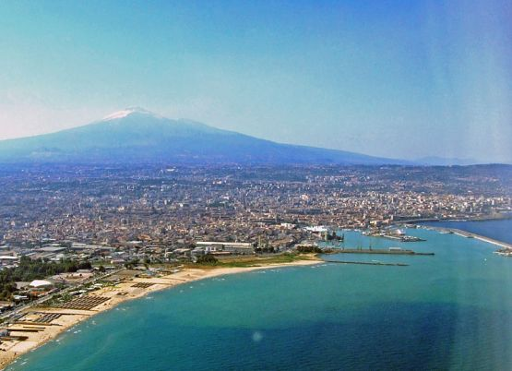
Visiting the volcanic craters…

First, we have to decide what we want to see on the volcano.
Mt. Etna is a very active volcano and when it is active the lava is visible from security distance or, at night, as a red flood, from the villages around the volcano.
However it's always possible to visit the extinct craters. The most famous are the "crateri silvestri", located on the south side of the mountain. This is probably the most classic way to visit the volcano and it's possible to buy excursions in many hotels or local travel agencies.
A smooth street makes it possible, also for tourist busses, to arrive at 1900 metres at the mountain station Rifugio Sapienza).
It's possible to visit the crateri Silvestri by your own, the walk takes about 30 min. -1 hour. At the mountain station rifugio Sapienza you will also find souvenir shops, bars and restaurants.

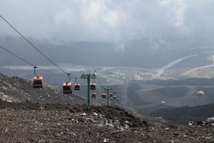
There's also the cableway station of the funivia dell'Etna. Here it's possible to buy the simple cableway ticket (price: € 30) which will take you at 2500 METRES or the complete ticket cableway+jeep bus which will tak you at 2900 metres (price: € 60). If you decide to go up we always suggest to take a complete trip because it's more spectacular.
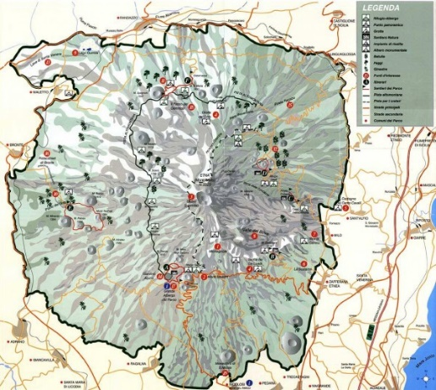
A guide will escort you to see some active side craters: it's often possible to see the craters steaming and you will touch the warm rocks due to the volcanic activity.
It is recommended to wear comfortable shoes and to take a jacket with you, also during the summer months. At that height it's often possible to find snow. For security reasons it's possible to arrive at the main crater only during certain periods. You will have to ask for information on the spot. The roundtrip from Rifugio Sapienza with the cableway and the jeep bus will take about 3 hours.
Recommended period: | from April to November
Scheduled day: | from Monday to Sunday
Duration: | 1,5 -7 hours (depends on the excursion )
Starting point: | near the cable-car of Funivia dell'Etna (ETNA SUD)
Participants: | min. 8 pax
Recommended equipment: | We advise a good pair of trekking shoes, an anti-wind and anti-rain jacket, an hat, telescopic sticks in order to help itself in the walk (only if you already have those), and in general dress appropriately to the various temperatures that is possible to find during the excursion.
READ MORE…
Mount Etna is the tallest active volcano in Europe, a majestic giant overlooking the city of Catania, in eastern Sicily.
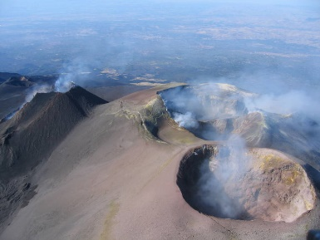
It’s the highest summit in Italy, apart from the Alps; being a volcano, its size changes constantly during the time. At this time , it is around 3.343 metres with a diameter of 45 kilometres.
On Mount Etna there are several summit craters. There are two central craters, called Bocca Nuova and Voragine; the Northeast crater; and the newest Southeast crater, which was formed by an eruption in 1978.

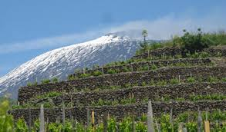
It’s a stunning touristic destination with delightful quiet towns and skiing stations.
Over 1500 metres there are cultivated and forested areas because the lands are ideal for agriculture, thanks to the particular fertility of the volcanic debris.
And that’s why some of the most delicious Sicilian wines, honey varieties and mushrooms grow on the Etna’s slopes.
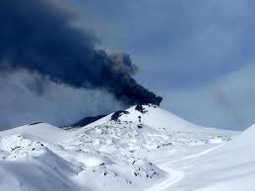
The Etna presents a great geological variety and landscapes : 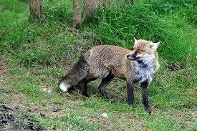 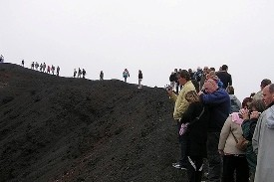
forests with endemic species, deserted areas covered in volcanic rock and subject to snow conditions. This is why its territory has been included in the national park of the Etna.
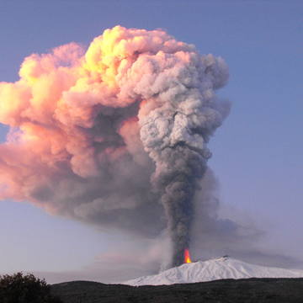
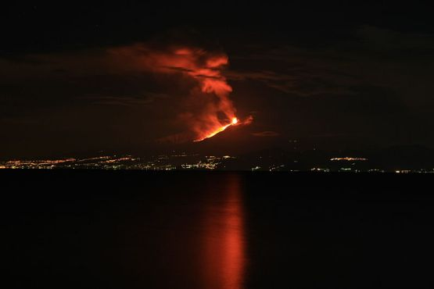
In 2013 the Mount Etna has been declared Unesco world heritage
The eruptions of Mount Etna have dramatically changed the landscape over the years, menacing the people who have lived at the base of the volcano.
The beauty of a lunar landscape, the views over the the seas and the volcanic activities are a must-do experience when visiting Sicily and the area of Catania.

